**SWIFT OPENSTACK**

**WHAT IS SWIFT?**

OpenStack Swift, also known as OpenStack Object Storage, it is a  [open source](https://www.techtarget.com/whatis/definition/open-source)  software designed to manage the storage of large amounts of data cost-effectively on a long-term basis across clusters of standard server hardware

OpenStack Swift software is based on Cloud Files technology developed by Rackspace Hosting Inc

OpenStack includes compute, storage and networking components for building cloud computing services.

Common use cases for OpenStack Swift include the storage, backup and archiving of unstructured data, such as documents, static web content, images, video files, email and virtual machine images.

HOW IT WORKS

OpenStack Swift stores data as binary objects on the server operating system's underlying file system. Each object has associated metadata as part of the extended attributes of the file

The Swift software supports replication and erasure coding across the storage [nodes](https://www.techtarget.com/searchnetworking/definition/node) in the server cluster. Swift places copies of every object in locations that are unique as possible first by region, then by zone, server and drive. If a server or hard drive fails, OpenStack Object Storage replicates its content from active nodes to new locations in the [cluster](https://www.techtarget.com/whatis/definition/cluster)

STORAGE DEVICE

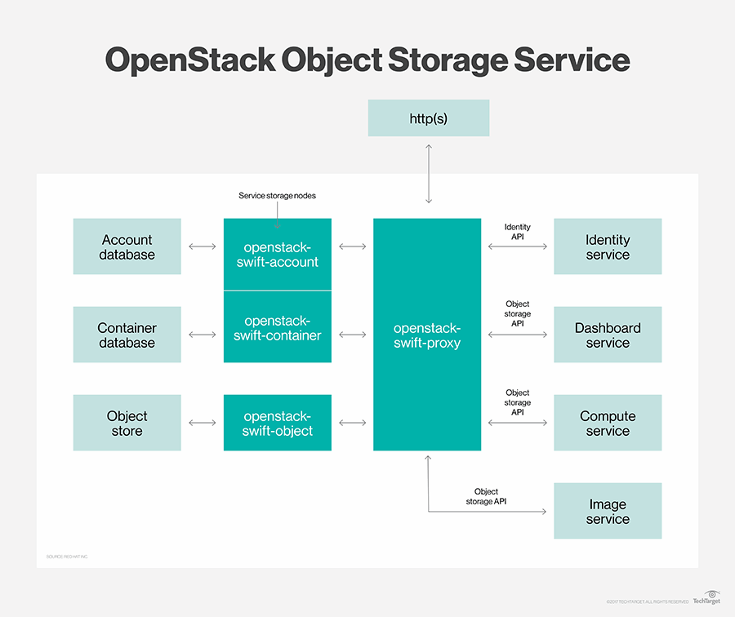

The  object storage system scales horizontally to store petabytes of data through the addition of server nodes, which can be equipped with hard disk drives or solid-state drives

OpenStack Swift uses a ring to map the object storage data to server [partitions](https://www.techtarget.com/searchstorage/definition/partition). The system uses a separate ring for services such as account, object and container. A ring builder constructs and manages the rings, assigns partitions to the storage devices, and pushes configuration information to the storage nodes.

| WEBSITE | https://www.techtarget.com |
| --- | --- |
| ORGANIZATION NAME | OPEN STACK |
| LICENSE OF THE PROJECT | Apache License 2.0 |

**Features of open stack swift**

It works on storage capabilities, drivers and bug fixes designed to improve the performance, stability, reliability, scalability and usability of the object storage software.

Many project team members are employees of technology vendors that sell products based on OpenStack Object Storage or the Swift API.

The OpenStack Swift project team releases a major update twice a year, as do the teams that support other OpenStack projects.

* Compatibility and portability
* Security
* Management and visibility
* Cloud storage
* Quality control

ARCHITECURE OF OPEN STACK

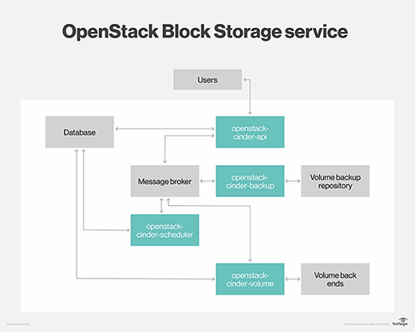

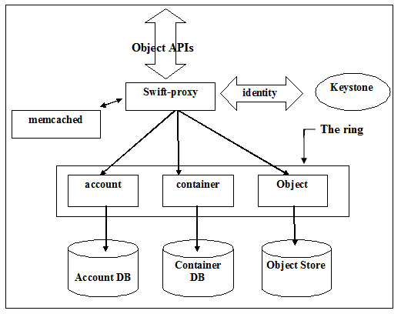

**CURRENT USAGE**

**OpenStack Swift include the storage, backup and archiving of unstructured data, such as documents, static web content, images, video files, email and virtual machine images.**